Dear ___________________,
I would like to invite you to an event coming up on Friday May 13th, 2022. The event features Dan Fisher, a pastor from Oklahoma, who will be presenting on the critical role of religious leaders according to our Founding Fathers. I have a strong testimony that fighting for our freedoms—including religious freedom—is part of building Zion in these latter-days.
I hope you can attend this event either in person or via Zoom. It will be a great evening of learning for our whole community!
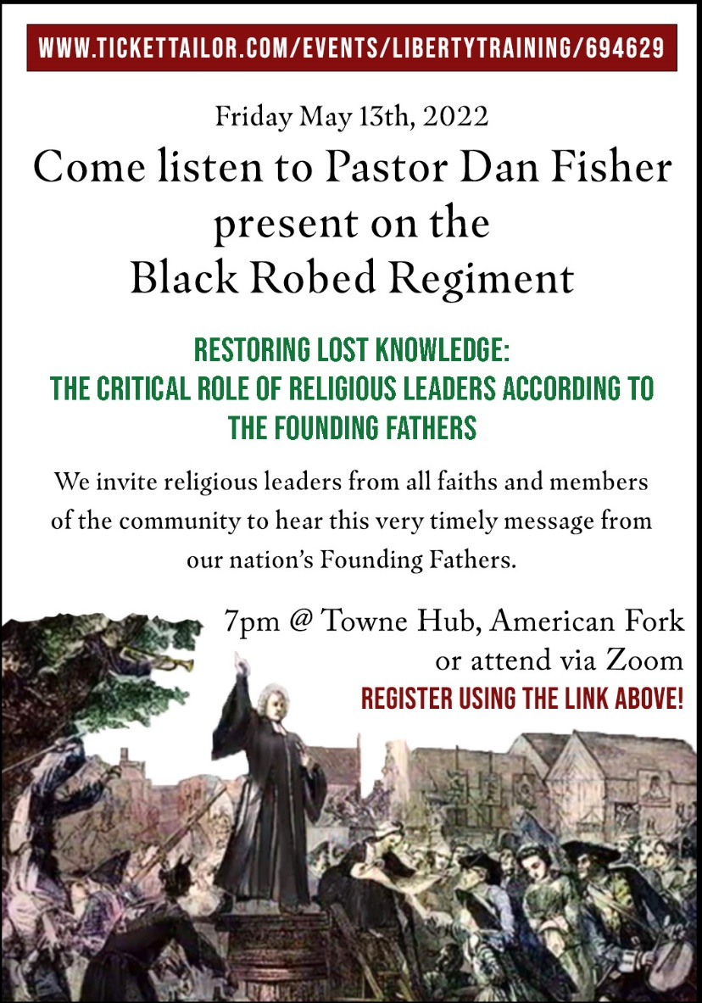

Sincerely,

Register here: https://www.tickettailor.com/events/libertytraining/694629

